Breaking the Ice With Student-Made Videos
Combining the six-word memoir with a film containing six shots gives students a way to introduce themselves at the beginning of the year.
By Marcos Cortez
June 21, 2019 https://www.edutopia.org/article/breaking-ice-student-made-videos
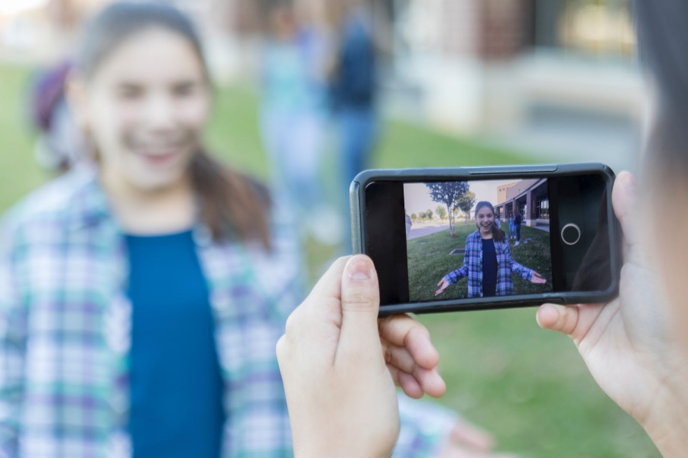
I came upon the work of Don Goble, a multimedia instructor from St. Louis, Missouri, and his Six-Word Story, Six Unique Shots project when I was struggling with how to begin a new year in a new way. Letters from students and poster board montages bored me. The feel of a glue stick gave me hives. Don’s project gave me pause. At that time, I had never made a film and my phone’s camera challenged me. However, I took a breath and ditched the traditional. The results amazed me.
Six-Word Story, Six Unique Shots is a spin on the popular six-word memoir activity. Students begin by writing a six-word memoir, typically exploring their identity. They then create a 30-second film using only the six words of the memoir and six different types of film shots.
The structure offers students an opportunity to deeply dive into their own interiority—or not. Students share stories of addiction, body image issues, and anxiety. They also create films hailing their love of coffee. The degree of vulnerability is truly up to the individual.
You don’t need to be tech savvy or possess fancy equipment to pull off this project. All you really need is a desire to do something different. I’ll detail the schedule I use with a 90-minute block period.

A Fun Bit of Self-Exploration
Day 1: My students and I begin by analyzing Goble’s students’ examples. We discuss what an example tells us about the person. We talk about how an image communicates an idea and how a word supports an image and vice versa. Students begin drafting their memoir in class. They can complete their memoirs at home or in class, if you have the time.
Day 2: We start this day by learning about the effects of different film shots. When is an extreme close-up most impactful? How does a low angle give the subject more power? Action movies work great for analyzing shot types because so much of the emotional intensity and audience engagement relies on the director’s choice of shots.
Day 3: Now is the time for students to storyboard their six-word memoirs into films. A storyboard is a series of small panels in which students sketch the look of a specific shot. It’s essentially a rough draft of their film; when completed it has the appearance of a comic book. Students begin to focus on both content and the logistics of the project. Are the shots different from one another? Where is the ideal filming location? Are any props or costumes needed?
Artistic talent is secondary here—stick figures are fine. What’s important is for students to align the purpose and weight of a word with the most effective shot. Considering the connection between word choice and meaning is something all developing writers can learn from doing.
Day 4: Today is the start of filming. Students may come in with fancy cameras, but most will probably use their phones. Before students begin filming, let them know that horizontal filming is a must. If they film vertically, the end result will be more difficult to edit, and it will look odd on screen. I use a fun tutorial (3:00 min) to bring this message home; you should preview the video to ensure that it’s appropriate for your classroom.
Day 5: Today students edit their films. There are essentially two options for editing hardware: the students’ phones or computers with editing software such as iMovie, Final Cut, or Adobe Premiere.
Editing on the phone is the simplest way to get a great final product. Typically, iPhones come with a version of iMovie. Adobe Premiere Clip is a free editing app that works well with Android phones. With either program, the basic editing functions are easy to use.
Using computer software allows students many more advanced editing options, but I suggest keeping it simple. The Mac program iMovie is the easiest software to use and provides the basic editing options students will need. Final Cut Pro and Adobe Premiere Pro are considerably more advanced (and not free).
Often, the most challenging part of the editing process is getting the footage from the phone to the computer. If the students have a Google account, they can access their footage from any computer. Students have to download the footage before placing it into any editing software. Students can also use Apple’s Airdrop feature to transfer the footage, or a USB cable works well with both Apple and Android phones.
Once the film is complete, students share their final product with me by using Airdrop to send it to my computer, saving it to a hard drive, or sharing it with me via Google Drive. This allows me to review the work outside of class and to show each film on the big screen without needing to hook up each student’s individual phone or computer.
Day 6: Film premiere! Bring the popcorn and get comfy.
Six days is a significant time investment, but consider the potential end product: engaged students with new skills, and a strong, safe class community.
Top of Form

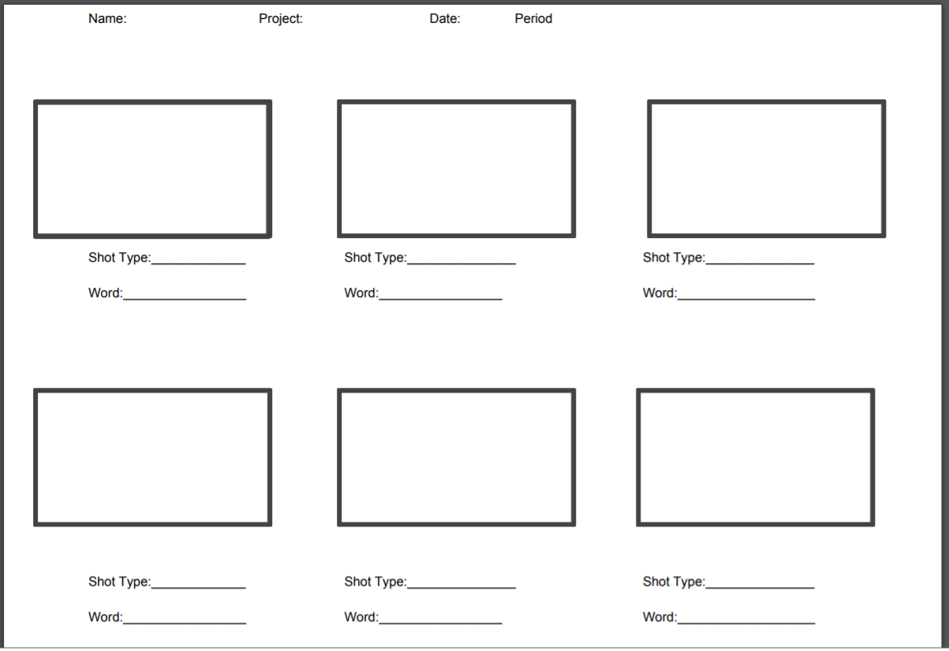
Bottom of Form

