Writing a Treatment

A treatment presents a clear synopsis of your storyline or demonstration/tutorial. This is the first step in organizing ideas for developing a short video or longer documentary.

A professional treatment (such as for a TV documentary) generally includes the program’s overview and objectives, the creative concept, technical approach, potential contributors, and a project timeline. A production’s treatment is critical in solidifying the producer - client agreement on the scope and development of the program.

One way to start your plan is to develop ideas using index cards or sticky notes. By the time you’ve written a dozen or so cards, you not only have a presentable short notes-style video treatment for the storyboard, committee, or your film crew. but now you can move things around as elements of perceived importance shift in importance.
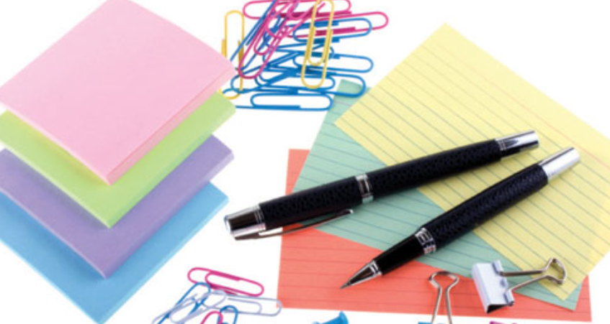
This strategy provides you and your team with the beginning of your storyboard and video script or voiceover.
Use the planning template on the following pages to begin planning your video and script. If you are making a tutorial video, you might want to read the directions for planning a Structured Micro Lesson (also posted here).
Then use the storyboarding template (also posted here to plan a sequence of shots.

Writing a Treatment
List Film Crew Members:
Title:
Target Audience:
Narrative description – Briefly describe the storyline:

Talent  (Who will take each part) | Role in Video (e.g., character) | Short description for each

Location(s) for the shoot - Describe (each) Setting:
Props needed?

Special techniques (e.g., camera, lighting)?
Sound tract/audio (e.g., music, sound effects)?

