Structured Video Micro Lessons from Connecting with Students Online
https://blog.heinemann.com/jennifer-serravallo-on-engagement-in-the-online-classroom
What It Looks Like—Microlesson – See short video at the above link (under 3 min.)
What does highly engaging instruction look like in remote or hybrid classrooms? How do you keep it simple but effective? Here's one example. Jen made this engaging microlesson in under ten minutes using the Clips app. As you’ll see, Jen not only uses arresting visuals, she also keeps the video to three minutes or less as suggested by research.
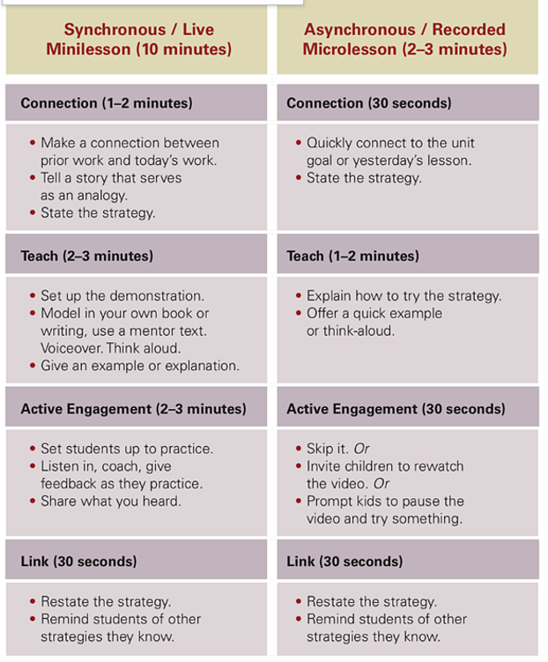
Karin’s Summary of Guidelines for Microlessons
- Begin with a general connection (real world, prior learning, a question about something many have observed or experienced)
- Keep the microlesson under 5 minutes – Chunk a longer lesson into key parts for recording several segments
- Model/demonstrate/do --- telling is not as effective as SHOWING YOURSELF (or a student) doing it while you are “thinking out loud.”
- If it’s a bit longer, insert places to pause and have students try /practice it. “Pause the video and try/do this. Observe and record what happens. Then turn the video back on to check your understanding.”
- End with a short summary of key points and practice task or assignment.

