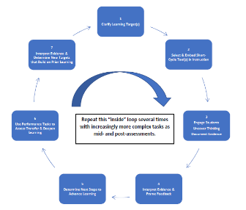 | Applying the Actionable Assessment Cycle  Matching Learning Targets to the Five Essential Teacher Moves  Adapted Planning Tool for Figure 7.2 (p. 160)  Title of Unit of Study or PBL Examining Author’s Craft
Identify the Broad Learning Goal/Competency:  The student will analyze how an author’s content and rhetorical choices communicate a text’s purpose. |  |  | Create an Overarching Essential or Driving Question (RbD, pp. 40-41)  How do authors use rhetorical strategies to communicate the content of a message?
Clarify Learning Targets |  | - Underline key learnings in unit goal.  - Create Learning Targets from skills/concepts underlined.  - Order the series of Learning Targets from least to most complex to guide instruction. | Select Strategies for Each Learning Target to Uncover Thinking  (Use end-of chapter summaries for ideas)
Embed Short-Cycle Tasks of Increasing Complexity  - Engage Students, Uncover Thinking  - Interpret Evidence  - Determine Next Steps |  | I can view a piece of persuasive media and identify the rhetorical strategies used | Students use a jigsaw activity to locate rhetorical strategies used in different media messages
 |  | I can determine author's theme and purpose when viewing a piece of persuasive media | Partners discuss and annotate texts
 |  | I can compare and contrast the use of rhetorical strategies between authors on a particular topic | Complete a graphic organizer comparing use of rhetorical strategies used two media examples on the same topic (e.g., ads, speeches, articles)
Use Performance-Based Tasks of Increasing Complexity to Assess Transfer  - Engage Students, Uncover Thinking  - Interpret Evidence  - Determine Next Steps |  | I can evaluate the impact of an author's use of rhetorical strategies in a piece of persuasive media
 |  | I can effectively use rhetorical strategies in my communication with others that best fit my audience to prove my point of view
 |  | I can evaluate my use of rhetorical strategies for an intended audience

Applying the Actionable Assessment Cycle
Matching Learning Targets to the Five Essential Teacher Moves
Adapted Planning Tool for Figure 7.2 (p. 160)

Title of Unit of Study or PBL
Identify the Broad Learning Goal/Competency: |  |  | Create an Overarching Essential or Driving Question (RbD, pp. 40-41)
Clarify Learning Targets |  | - Underline key learnings in unit goal.  - Create Learning Targets from skills/concepts underlined.  - Order the series of Learning Targets from least to most complex to guide instruction. | Select Strategies for Each Learning Target to Uncover Thinking  (Use end-of chapter summaries for ideas)
Embed Short-Cycle Tasks of Increasing Complexity
- Engage Students, Uncover Thinking
- Interpret Evidence
- Determine Next Steps

Use Performance-Based Tasks of Increasing Complexity to Assess Transfer
- Engage Students, Uncover Thinking
- Interpret Evidence
- Determine Next Steps

